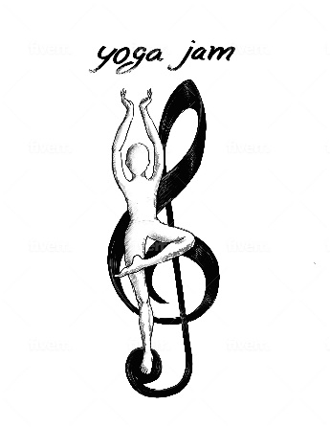

**2025 Yoga Jam Retreats**

**May 2nd – May 4th, Sainte Adele, QC, Canada**

Come join me Friday through Sunday in the beautiful Sainte-Adele, QC. We’ll be staying in a French-style rustic chalet where all locally-sourced, organic meals will be provided. Alternatively, you may also choose to stay in a 2 bed or private room on the property.

Activities include: daily meditation and yoga, an improv session, a music workshop and jam, a memoir writing workshop, and a chakra opening ceremony. Also included is a day pass to the wonderful outdoor heated spa and sauna offered by the property and local nature walks/hikes as you desire. All activities are optional but encouraged. We will explore our creative selves while focusing on what it is that we really want in life. Tuning into our souls, we will learn to trust our intuition and build upon what we learn in this retreat about ourselves.

Meals will be home-cooked and nourishing using locally-sourced organic foods, when possible. A gift is included upon arrival.

**Oct 10th-12th, Cobb, California**

Come join me in the beautiful Mayacamas mountains just north of Napa Valley in Cobb, California. Local organic, vegetarian meals will be provided. Accomodations include single, double, and triple cabins or cottages located amidst the beautiful fall foliage of the Mayacamas mountains.

Activities include: daily meditation and yoga, an improv session, a music workshop and fire-side jam, a memoir writing workshop, and a chakra opening ceremony. A pond with paddleboats is located on the property, as well as bikes, a swimming hole, and many hiking areas. There are also meditation decks and a labyrinth for those who wish to deepen their personal practices. All activities are optional but encouraged. This retreat will leave you with lasting memories, a greater understanding of yourself, compassion for yourself, and an opening of your creative energy.

Meals will be home-cooked and nourishing using locally-sourced organic foods, when possible. A gift is included upon arrival.